
Computer Networks Lab_241L
UW-24-CS-BS-101
Registration NO:
Muhammad Talha_CS.3ndB
Lab Sessional
UNIVERSITY OF WAH(UOW)

DEPARTMENT OF COMPUTER
SCIENCE

COURSE:

SUBMITTED TO:

Mr. Hassan Shafaqat
SUBMITTED BY:

Adding PC’s to Screen
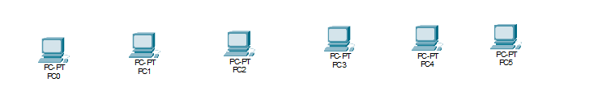
Adding Switches and Routers
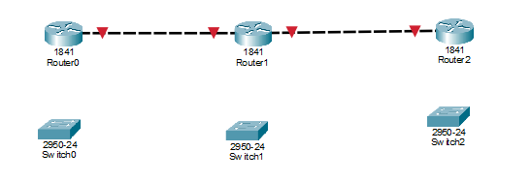
Connecting Switches to Routers
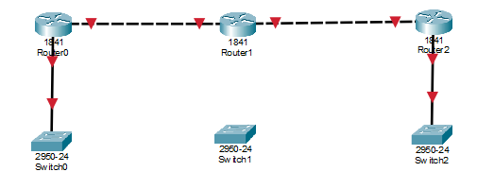
Connecting PC’s to Switches
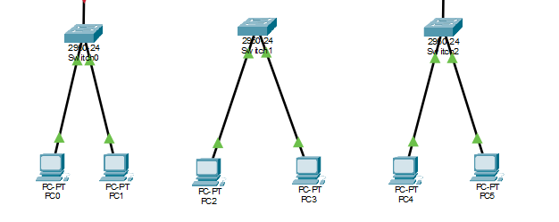

Linking Routers
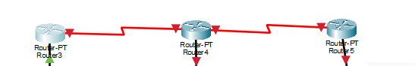
Adding Bandwidth
Router 1
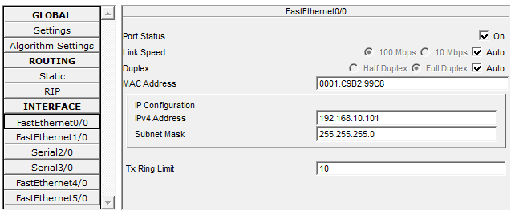
Router 2
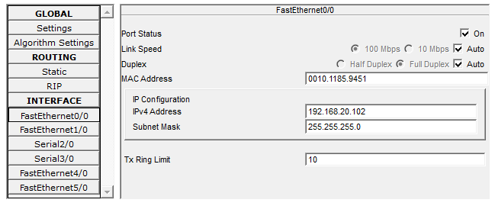
Router 3
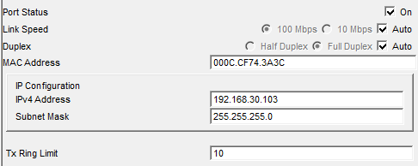

Adding Address to each pc’s
PC1
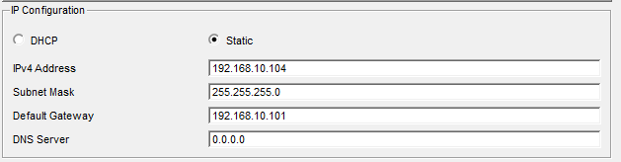
PC2
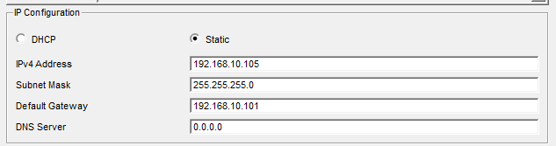
PC3
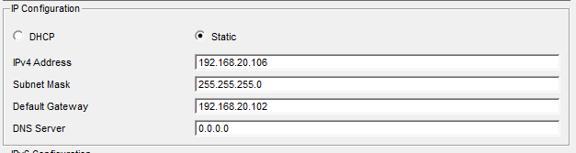
PC4
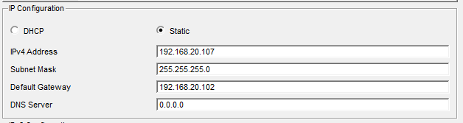

Adding addresses Comments
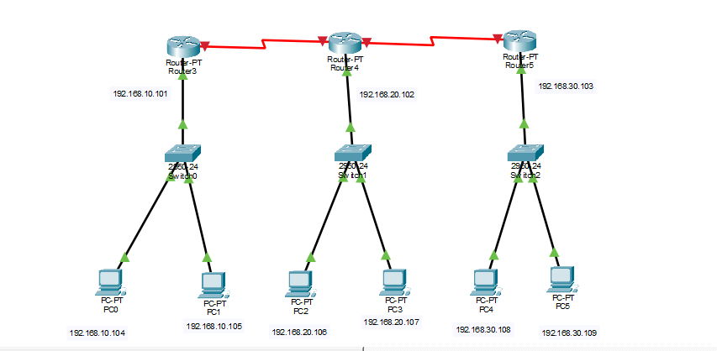
Static Routing
Router 1
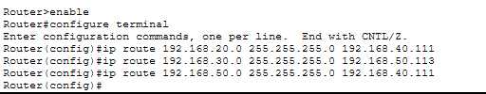
Router 2
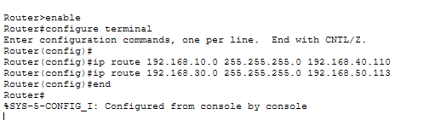
Router 3
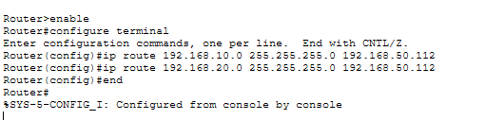

Static Routing Done

Whole Structure
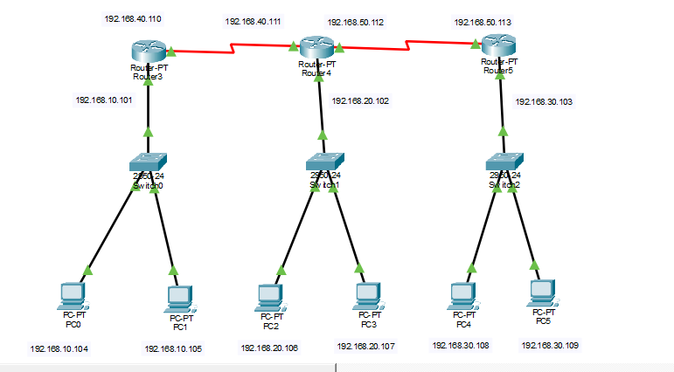
Sending Messages
From PC0 to Each Device through ping
To PC2
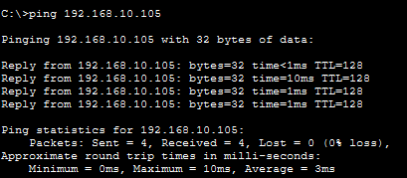
To PC3
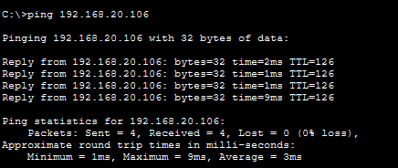

To PC4
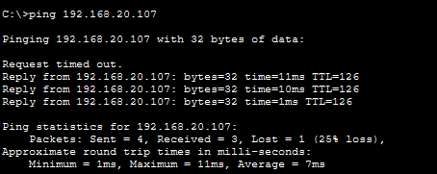
To PC5

To PC6

From PC1 to Each Device through ping
To PC1
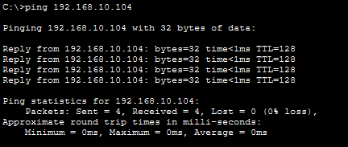

To PC2
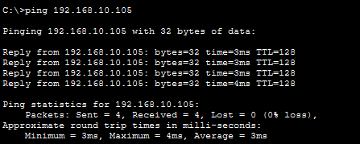
To PC3

